English and Literature
Name
Institution

DON’T WORRY I SHALL BE GENTLE WITH YOU MY DARLINGS
BY: SANAM KHABITI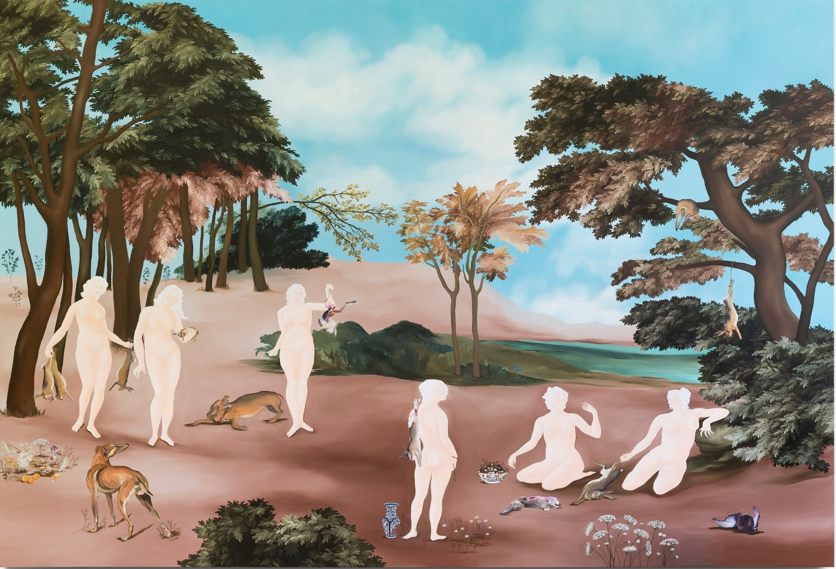
Don’t worry I shall be gentle with you my darlings. 2017. By Sanam Khabiti

Sanam Khabiti is a Belgian artist who was born in 1979 in Tehran Iran. The artist lives and works in Brussels city in Belgium where his main work includes painting, embroidering, tapestrying and sculpturing. Sanam’s work captures the themes of human primitive instincts and animosity, the changing aspects of men and women, power equality among different genders, submission and domination, as well as fear and desire (Sanam,n.d). Khabiti’s work is quite famous and has been shown in several solo and group exhibitions both in Europe and the United States. Khabiti’s work has found its inspiration from several factors such as Frida Kahli, Henry Dager and Hieronymus Bosch cities as well as other works of literature and classical mythology such as Persian’s mythological works.
Khabiti is a self-taught artist whose work is believed to be steered by his own natural instincts. Khabiti believes that his work is meant to reveal the primitive character which human beings try to cover. He believes that despite how hard the society tries to hide the human primitive instincts, despite how educated and polite we are, we still possess a primitive desire. Thus, each of khabiti’s work strives to capture these human desires such as the asexual game, romantic or savage actions and the tenderness or brutality in human nature (Rizzo, 2017).
Although the underlying themes of Khabiti’s work are kind of undesirable, his work captures a lot of kindness. Although most of her work consists of violent scenes, the artist maintains a sense of happiness at his festivals. Additionally, her subjects who are usually female are depicted as protagonists rather than victims. In his work women pursue, tame or attract wild animals instead of being wasted by them (Sanam,n.d).

The above artwork “Don’t worry I shall be gentle with you my darlings” was done by Sanam Khabiti in 2017. The above artwork creates rebirth imagery, where the naked women commingle with wild animals who are perceived as dangerous, yet they pose the desire to play with these less-superior creatures whilst still fearful and vulnerable to these creatures (Sanam,n.d).
The nudity of the women figures, tend to show how they are extremely willing to create a natural ambiance with these animals and also comfortable with them. In the artist’s paintings, the animals seem unsure of these women’s intentions considering they are the predators whilst their handling of the creatures they are toying with, seems to puzzle these other animals who are not yet interacting with them.
Don’t worry I shall be gentle with you my darlings (The Poem)
Today I will be gentle;
Today I choose ceremonial fauna.
The flora has created the ambiance and my playful nature has aroused.
Fearful! Yet today I want to toy with these animals.
My nose smells them my mouth stays closed but my paws will be all over them
I believe they are a reflection of us.
Today I will unwitty them with my unbounded love, draw them with my touch.

Confused, yet tempted they are in desire for our attention.
Yes I am powerful, violent and dangerous but today my radical instinct trumps
I mean no harm, come close and get comfy with me
Today you will give me company
You will give me fun and satisfaction with my touches
Today I am not bloody you will crawl on me, scratch and I will not be vindictive!
You will love my nature when you know I am part of you.

References
Fiona Stafford. (2016). Art and Poetry. Retrieved from; https://www.tate.org.uk/research/publications/in-focus/pegwell-bay-kent-william-dyce/art-and-poetry accessed 2019-01-27
Sanam Khatibi. Retrieved from; http://sanamkhatibi.com/about/ accessed 2019-01-27
Rizzo, C. (2017). Artist Reimagines Renaissance Era Paintings with Powerful Women. Retrieved from; https://www.vice.com/en_au/article/ywgg4j/artist-reimagines-renaissance-paintings-powerful-women

